**You Wu**

Date of Experiment: 12/02/2014

Date of Report: 12/08/2014

**ECE 221 Lab #6: BJT DC biasing and BJT common-emitter amplifier**

**Part I**

The circuit in figure 2 was built and IE was measured to be 2.3mA. IB was measured to be 16uA. So $β= \frac{I_{C}}{I_{B}}-1= \frac{2300}{16}-1=142.75$. From the data sheet and under the circumstances of the next part where IC = 2mA, beta can be calculated to be 50-300.

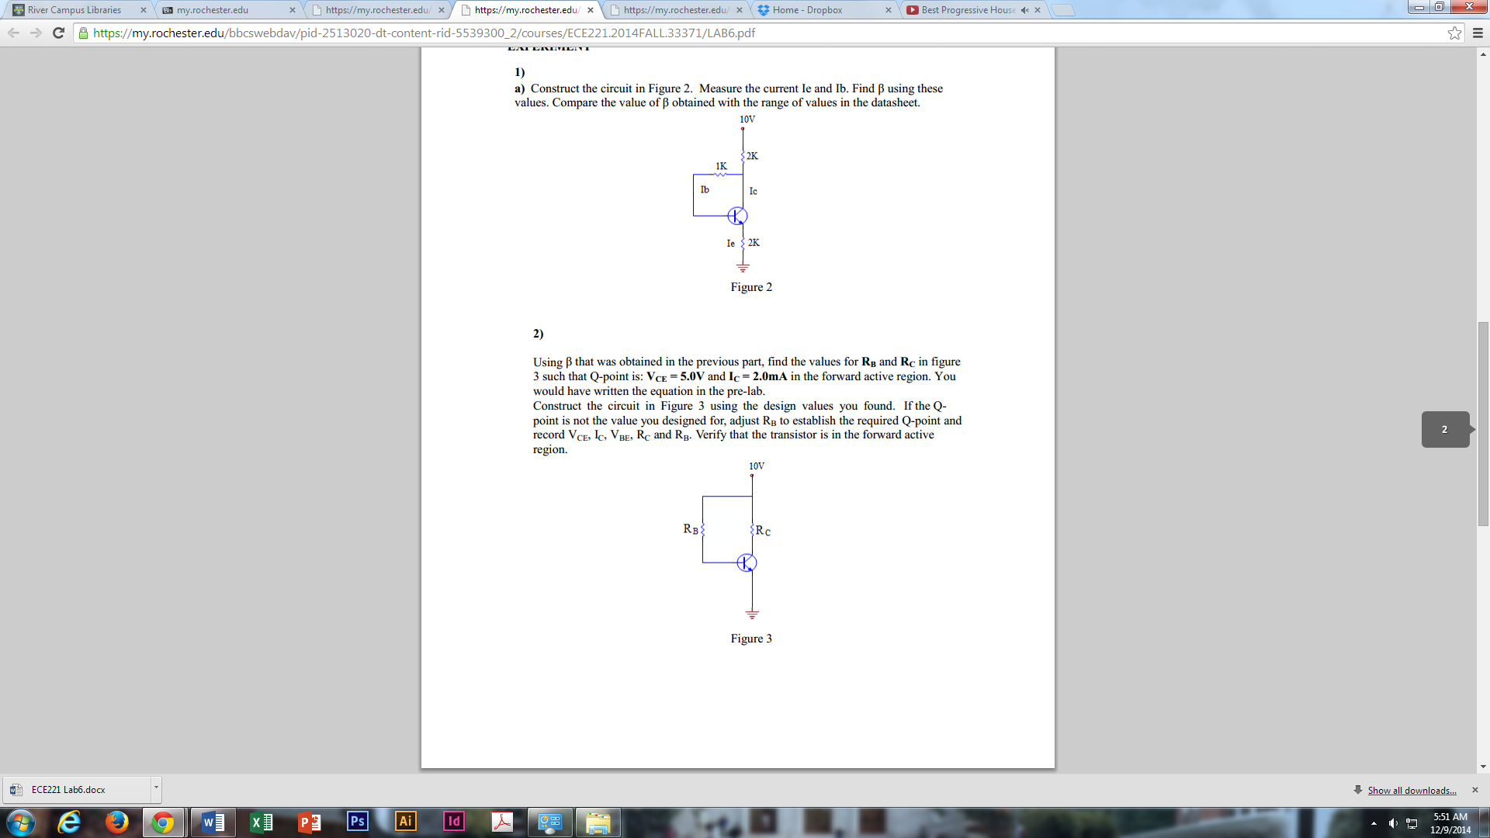

**Part II**

The circuit in figure 3 was built with VCE = 5.0V and Ic = 2.0mA. VC = 5V so RC = (10-5V)/2mA = 2.5kΩ and RB = = 620kΩ. VCE was measured to be 4.9V. Ic = 4.9V/2.5kΩ = 1.96mA. VBE = 0.66V. Since VC>VB>VE, the npn transistor is in the forward active region.



**Part III**

The circuit in figure 4 was built with Cin = 0.2uF. With no input signal applied, VC was measured to be 3.37V. So Ic = (20V-3.37V)/20kΩ = 0.832mA. And VCE = 0.56V. When a 10kHz signal with amplitude 1Vpp was applied, the waveform below was observed. Vout was observed to have an offset of approximately 13V with 1Vpp. Vin was observed to have an amplitude of approximately 16mV with 0V offset. This makes the small signal gain 13/.016 = 812.5. Rout of this amplifier was measured to be 20kΩ.

